
Year 8 Science 2015

Energy Topic Test - Modified

  - Name ____________________________
  - Teacher ____________________________
  - Score _____ / 36 _____ %

 | Which of the following is a form of kinetic energy?  - Motion  - Chemical  - Elastic  - Nuclear | A | 1
 | The energy we receive from the sun includes:  - electrical and sound energy.  - heat and nuclear energy.  - electrical and light energy.  - heat and light energy. | D | 1
 | The petrol needed to make a car move is a form of:  - kinetic energy.  - chemical potential energy.  - elastic potential energy.  - gravitational potential energy.  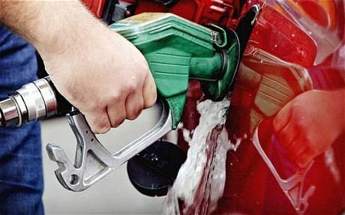 | B | 1
 | When a bicycle skids to a stop, its kinetic energy is mostly transformed into:  - heat and sound.  - potential energy.  - sound energy.  - heat and light.  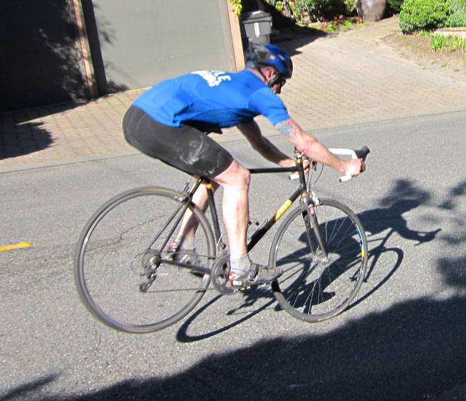 | A | 1
 | When you place a metal saucepan on the heating element of a stove, heat is transferred to the saucepan by:  - reflection.  - convection.  - conduction.  - radiation.  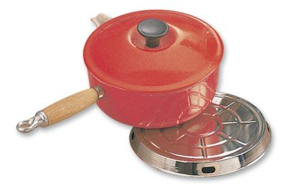 | C | 1
 | Which two types of heat transfer listed below are reduced by placing insulation in the ceiling of a house?  - Conduction  - Convection  - Radiation | A and B | 1
 | When you are active in cool weather, heat is transferred from your body by:  - radiation.  - convection.  - conduction.  - evaporation.  - all of the above. | E | 1
 | Which of the following can be described as being luminous?  - Streetlights (turned on)  - A road sign  - The moon  - Water  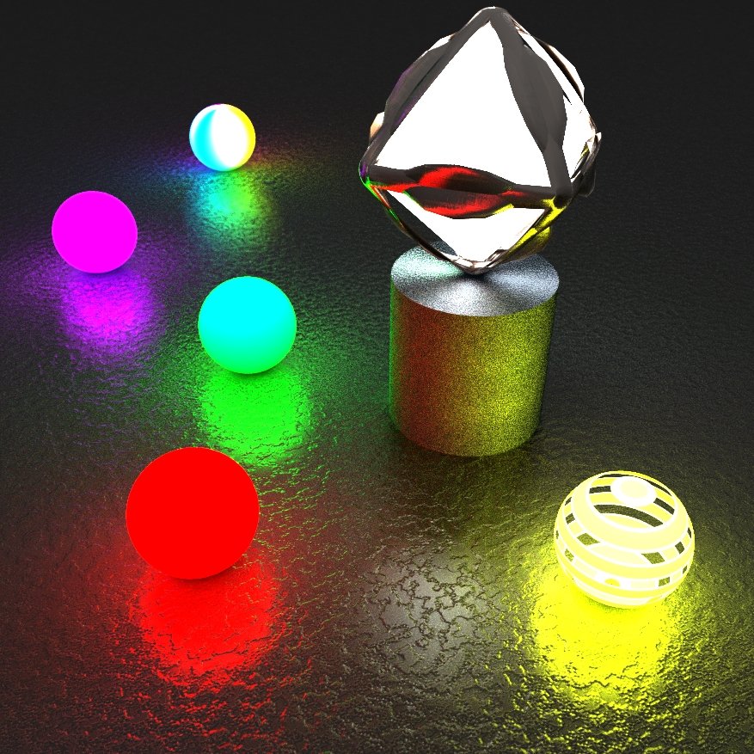 | A | 1
 | Name the odd one out.  - Guitar 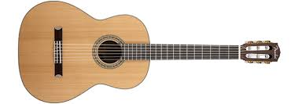  - Clarinet  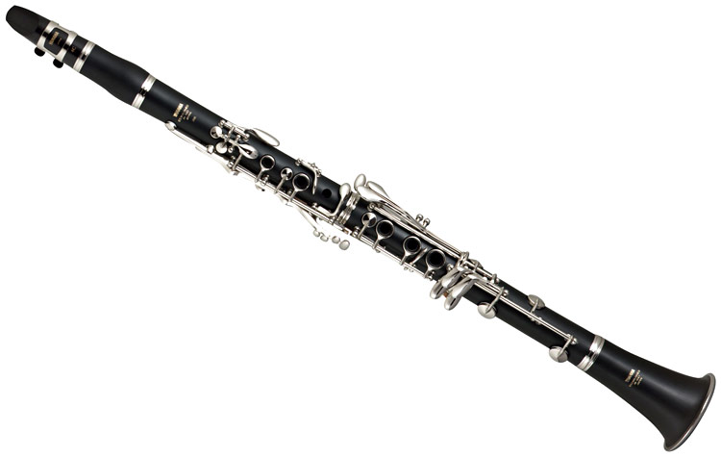  - Saxophone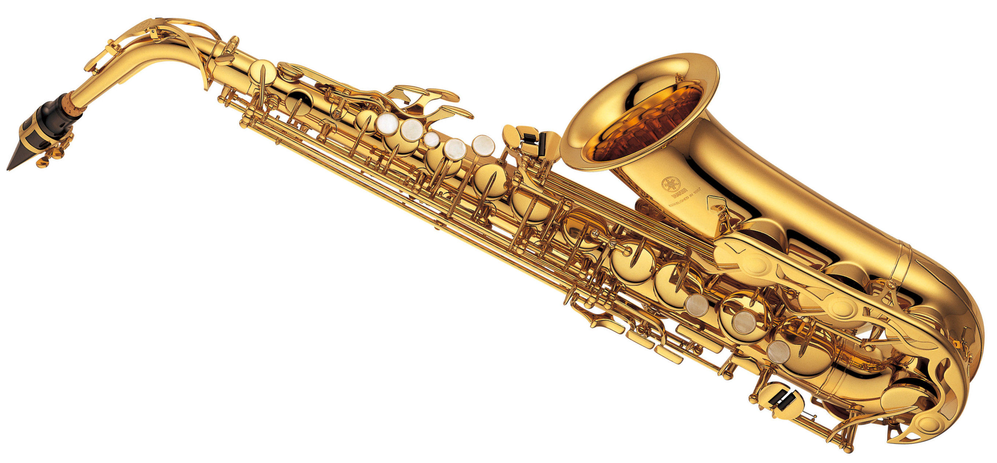  - Flute  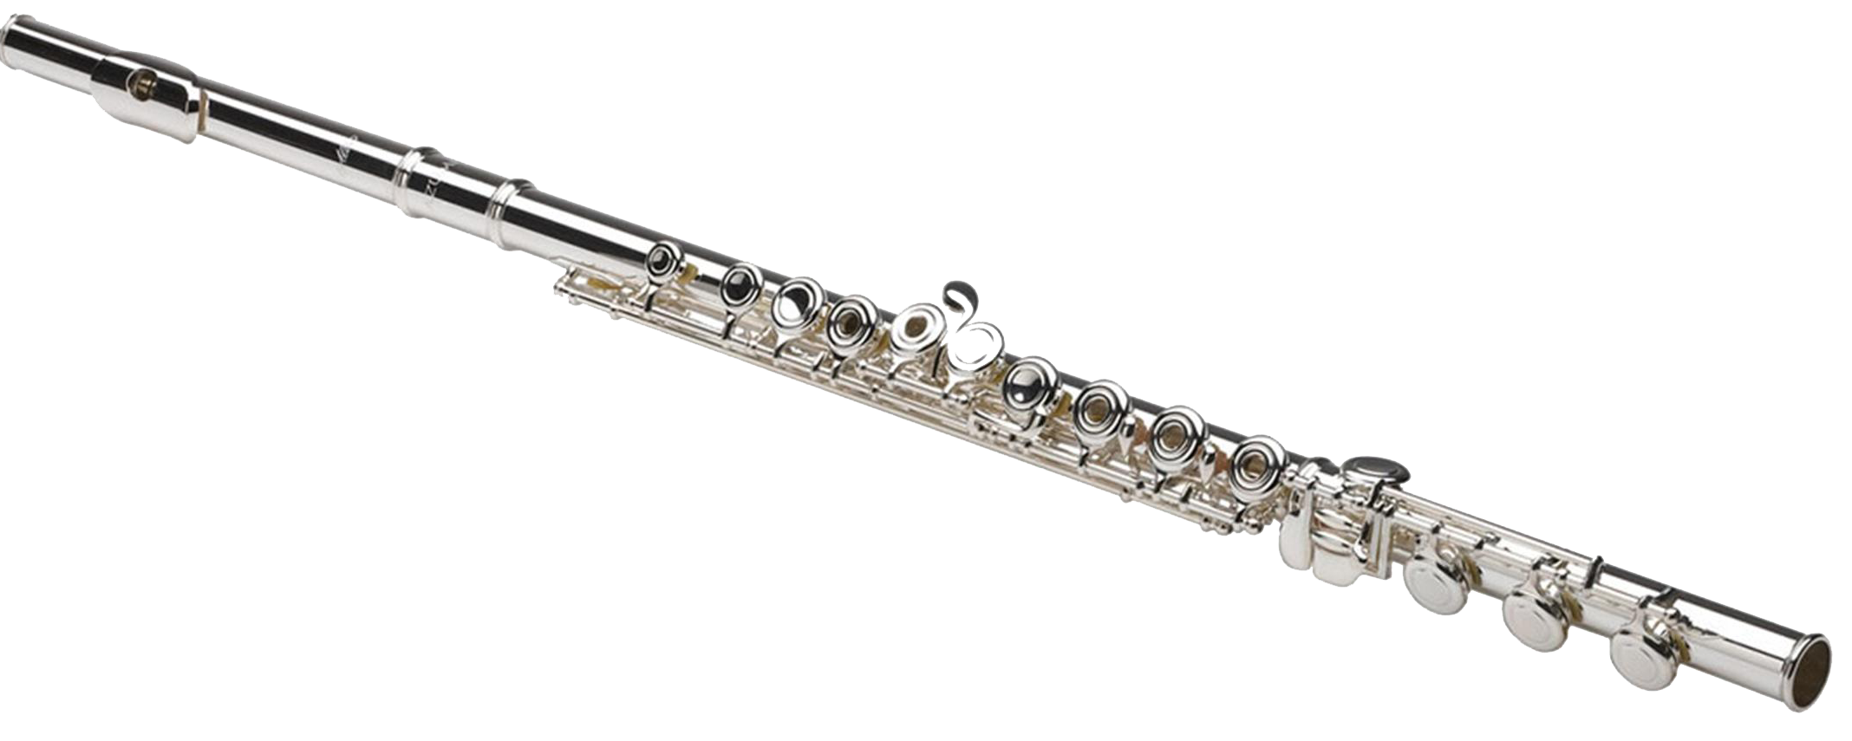 | A. The guitar is not a wind instrument requiring a column of air. | 1
 | In the burning of fireworks during New Year displays, chemical potential energy is converted into:  - heat, light and sound energy.  - light and sound energy.  - sound and heat energy. | A | 1
 | True or false:  - Energy can be transferred to another object.  - Energy can be stored.  - Energy can be created as well as destroyed. | - Energy can be transferred to another object. T  - Energy can be stored. T  - Energy can be created as well as destroyed. F | 3
 | Four different types of light globes were tested for their efficiency. The results are in the table below.  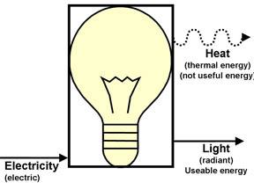  Globe number Heat output Light output  1 85% 15%  2 90% 10%  3 50% 50%  4 30% 70%  - What is ‘efficiency’? Use the words ‘input’, ‘output’ and ‘useful’ to help you explain.  - Which globe is the most energy efficient? Explain your answer using data from the table.  - What was the energy source (original form of the energy) that was converted to produce light and heat from the globe?  - Why is it better to have energy-efficient light globes? | - How much of the input energy is useful.  - Globe 4 has the most light output (70%) compared with heat output (30%).  - Electrical energy  - Most of our electrical energy comes from burning fossil fuels. By increasing the efficiency of light globes, more usable energy is produced and less energy is wasted. This reduces the amount of fossil fuels required to power the light globes. | 6
 | Name a something that changes:  - chemical energy into kinetic energy  - chemical energy into light energy  For example, a GAS HEATER turns chemical energy (from the gas) into heat energy.  Other kinds of chemical energy include food, petrol, batteries and chemicals in the lab. | Answers will vary. Examples are given.  (a) Car  (b) Torch | 2
 | 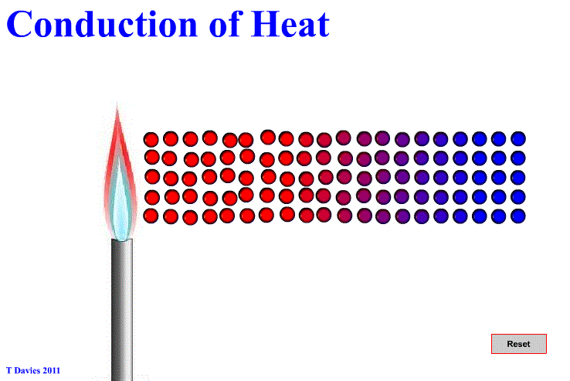  (a) Identify materials that are good heat conductors.  (b) What name is given to materials that are poor heat conductors? | (a) Metals  (b) Insulators | 2
 | List one place where heat is lost from a home during winter.  State how the heat is transferred and how heat loss may be reduced.  Heat is lost from a home through the  _____________________  It is transferred by (circle one)  Conduction Convection Radiation  You could stop this happening by…  ____________________________  ____________________________ | Answers will vary. Examples are given.  - Roof: Heat is lost by convection. Use fibre insulation to reduce heat loss.  - Windows: Heat is lost by conduction. Use double glazing to reduce heat loss.  - Walls: Heat is lost by conduction and radiation. Use cavity bricks to reduce heat loss. | 6
 | Draw a diagram to show an energy transformation (energy changing from one form to another) that you know about.  Here are some examples.  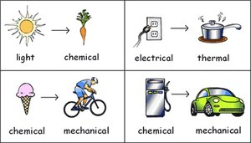 | Answers will vary. | 4
 | Is the moon luminous (produces its own light) or non-luminous (reflects the light from something else)? Give a reason for your answer. | The moon is non-luminous because it does not emit light of its own, but reflects the sun’s light. | 2
 | Why do you always hear thunder after you see the lightning that caused it? | Sound from thunder travels more slowly than light travels from lightning. | 1

